**Computer Architecture - Hardware, Network and Software**

**Assignment 1:** Draw your Home Network Topology and explain how you are accessing the RPS Lab environment.

**Diagram:**

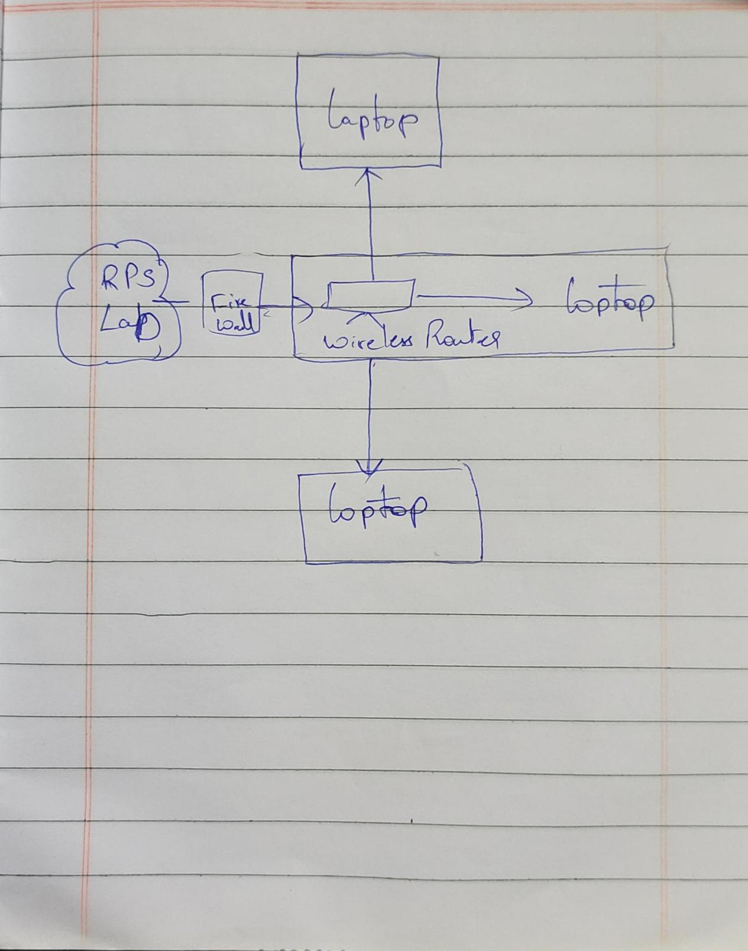

**Wi-Fi Router:** This is a internet service provider device, which helps in connects our home network to the internet.The network provided by the router is wireless network.

**Firewall:** This acts as a security from the server to the network provided by the router.

**Laptop/Mobile:** These devices uses the network provided by the router.

**Assignment-2:** Identify a real-world application for both parallel computing and networked systems. Explain how these technologies are used and why they are important in that context.

Parallel computing refers to the process of executing several processors an application or computation simultaneously. Generally, it is a kind of computing architecture where the large problems break into independent, smaller, usually similar parts that can be processed in one go. It is done by multiple CPU's communicating via shared memory, which combines results upon completion. It helps in performing large computations as it divides the large problem between more than one processor.

Parallel computing also helps in faster application processing and task resolution by increasing the available computation power of systems. The parallel computing principles are used by most supercomputers employ to operate. The operational scenarios that need massive processing power or computation, generally, parallel processing is commonly used there.

Typically, this infrastructure is housed where various processors are installed in a server rack; the application server distributes the computational requests into small chunks then the requests are processed simultaneously on each server. The earliest computer software is written for serial computation as they are able to execute a single instruction at one time, but parallel computing is different where it executes several processors an application or computation in one time.

There are many reasons to use parallel computing, such as save time and money, provide concurrency, solve larger problems, etc. Furthermore, parallel computing reduces complexity. In the real-life example of parallel computing, there are two queues to get a ticket of anything; if two cashiers are giving tickets to 2 persons simultaneously, it helps to save time as well as reduce complexity.

## Types of parallel computing

From the open-source and proprietary parallel computing vendors, there are generally three types of parallel computing available, which are discussed below:

1. ****Bit-level parallelism:**** The form of parallel computing in which every task is dependent on processor word size. In terms of performing a task on large-sized data, it reduces the number of instructions the processor must execute. There is a need to split the operation into series of instructions. For example, there is an 8-bit processor, and you want to do an operation on 16-bit numbers. First, it must operate the 8 lower-order bits and then the 8 higher-order bits. Therefore, two instructions are needed to execute the operation. The operation can be performed with one instruction by a 16-bit processor.
2. ****Instruction-level parallelism:**** In a single CPU clock cycle, the processor decides in instruction-level parallelism how many instructions are implemented at the same time. For each clock cycle phase, a processor in instruction-level parallelism can have the ability to address that is less than one instruction. The software approach in instruction-level parallelism functions on static parallelism, where the computer decides which instructions to execute simultaneously.
3. ****Task Parallelism:**** Task parallelism is the form of parallelism in which the tasks are decomposed into sub tasks. Then, each sub task is allocated for execution. And, the execution of sub tasks is performed concurrently by processors.

## **Applications of Parallel Computing**

* One of the primary applications of parallel computing is Databases and Data mining.
* The real-time simulation of systems is another use of parallel computing.
* The technologies, such as Networked videos and Multimedia.
* Science and Engineering.
* Collaborative work environments.
* The concept of parallel computing is used by augmented reality, advanced graphics, and virtual reality.